**indh Madressatul Islam University**

**Department of Software Engineering**

**2nd Semester Fall 2022**

**Software Engineering (SEN102)**

**Faculty Name: Syeda Wajiha Naim**

# **Assignment # 3 & 4**

**(Total Marks: 20)**

### **Deadline**

Your assignment must be submitted before or on **5th January 2023**.

### **Objective**

This assignment is designed to let you learn the concepts of software engineering.

### **Assignment**

1. As a project manager your job is to manage a team of developers that is going to build an application similar to the ones they have built earlier which means they have experience building such applications. The application that they are going to build now is more complex and larger one, and the requirements have been thoroughly explained and documented by the customer. Justify your choice of process model for this project. Discuss the valid reason(s) in detail.
2. Discuss T-shirt sizing technique of story points estimation in Agile.
3. Give example of Risk mitigation, monitoring and management (RMMM) plan. [Build up a table.]

**Instructions**

* Submit within due date.
* Write in your own words.
* On title page mention the following:

**Insert Logo of the University**

Underneath the logo write:

**Name:**

**Semester & Section:**

**Student ID:**

**Course ID:**

* Do not use rephrasing tool.

**TOPIC:1#The solution of contemporary political problems at that time in the light of the Prophet(صلی اللہ علیہ وسلم).**



Submitted By:

**(Muhammd Mubashir)**

**(BSSE** & **2B**)

(BSE-22S-084)

(Software Engineering)

Submitted To:

Miss Wjiha Naim

Sindh Madressatul Islam University Karachi

1.As a project manager your job is to manage a team of developers that is going to build an application similar to the ones they have built earlier which means they have experience building such applications. The application that they are going to build now is more complex and larger one, and the requirements have been thoroughly explained and documented by the customer. Justify your choice of process model for this project. Discuss the valid reason(s) in detail.

## **Waterfall Model Process**

**Communication**

Manager has organized a development team and asked them to create an application that is long and unique in that the customer has given the complete details . After that will go to planning.

**Planning**

After the communication is complete, now he will see what planning should be done first, like if someone wants to build a house, then he will first make a map etc. After that will go to Modeling.

**Modeling**

Now we are going to the design, now we will do the design, like when we are building a house, what color should we use, how should we do the floor, how should we install marble or tiles? After that will go toConstruction.

**Construction**

Now that we have done everything, we have done the communication, we have done the planning, we have done the modeling, now we are going to build the application, just like we need to mix everything first to build a house.After that will go to deployment.

**Deployment**

Now when everything is done, now user will see and he will check that what the user communicated to the developer is correct then he will do okay then developer will deploy.

**Reason**

The waterfall model is used because the communication that took place from the user to the communication, the requirements in the communication were fixed, nothing we had to implement what the user said would be fixed if the user He said that now you make any model, later we have to change it, then we would have used the V model because in the V model, we did communication first and then planning.

Then after that we remembered that we had to edit these things in the requirements, then we went to the communication again and in the communication we edited or again in the direct we went to the designing. If we remember that we have to edit this thing in the communication after doing the communication, then we can't go backwards because we used the waterfall model because it had the requirement fix.

2.Discuss T-shirt sizing technique of story points estimation in Agile.

##### **T-Shirt Sizing In Agile**

T-Shirt size estimation in Agile is a technique that uses relative estimation. This estimation technique is helpful in planning effectively for a longer time. The T-Shirt sizing technique is a tool that helps in both product estimation and capacity planning. It helps you in knowing how much time or effort a particular initiative will take. Usually, Agile begins with either a high-level estimation of the product or a macro view of the product. This means the teams are able to arrive at a long-term plan for the product. And one of the most popular techniques used for this purpose is t-shirt sizing which estimates story points using relative estimation. It estimates what time, budget, and effort would be required for a particular product. The T-Shirt sizing Agile estimation technique is particularly beneficial for those teams that have just started using Agile and want a relative estimation for a product. On the basis of the way you use this technique, a t-shirt size can depict the scope of the product, the effort needed for it, the work hours required for it, the complexity of the product, time estimates, or all of these.

The t-shirt sizing technique is based on the concept of basketing meaning items with similar sizes are grouped together. Teams mutually collaborate, discuss, and then arrive at a decision on size. The size of a User Story is set by the team relative to others. The t-shirt size estimation in Agile starts at a t-shirt size in order to plan the future releases. This planning is then split into story points for the purpose of Sprint planning. And the story points can be further broken into hours for executing Sprint. Irrespective of this, the important point here is that as the work gets closer and closer to a developer's keyboard, more accurate estimation becomes easier and smaller. The t-shirt planning works very well for defining the product blueprint and Release Planning.



3.Give example of Risk mitigation, monitoring and management (RMMM) plan. [Build up a table.]

**RMMM Plan** :

A risk management technique is usually seen in the software Project plan. This can be divided into Risk Mitigation, Monitoring, and Management Plan (RMMM). In this plan, all works are done as part of risk analysis. As part of the overall project plan project manager generally uses this RMMM plan

### ****Steps for Risk Management****

1. Identify possible risks and recognize what can go wrong

2. Analyse each risk to estimate the probability that it will occur and the impact (i.e., damage) that it will do if it does occur

3. Rank the risks by probability and impact. Impact may be negligible, marginal, critical, and catastrophic.

4. Develop a contingency plan to manage those risks having high probability and high impac

## **Risk Management**

A software project can be associated with a wide range of threats. It is necessary to classify risks into distinct classes in order to be able to systematically identify the critical risks that may harm a software project. After that, the project manager can determine whether risks from each category are crucial to the project.

These potential concerns could impact the project's cost, timeline, or technical success, as well as the performance of our software product and project team morale.

Risk management is the process of identifying, addressing, and resolving problems before they harm the project.

The risks can be broadly categorised into three categories, as illustrated below:

1. ****Project risks**** are those that have an impact on the project's schedule or resources.
2. ****Product risks**** affect the quality or performance of the product being developed.
3. ****Business risks**** are risks to the corporation developing or licensing the software.

This is not a unique classification. When an experienced programmer leaves a project, it poses a project risk since the system's delivery may be delayed. The product may be at risk because the replacement may not be as experienced, resulting in slip-ups and lost revenue.

Risk management is critical because of the inherent risks that most software projects confront. The figure below depicts the risk management process.

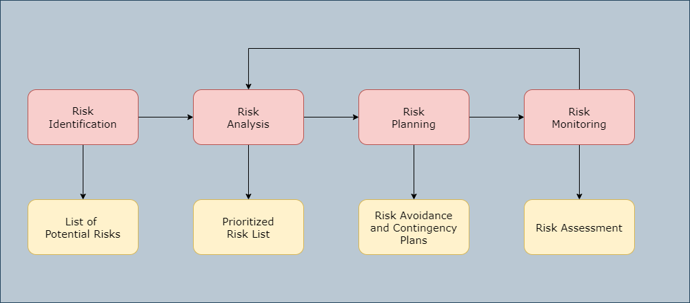

Like all other aspects of project planning, the risk management process is an iterative process that lasts throughout the project. The outcomes of the risk management process should be documented in a risk management plan. A risk management plan should include a discussion of the project's hazards, an analysis of those risks, and actions to mitigate those risks. It may also include some risk management outcomes.